**Gates Developments:**

**A Comprehensive Overview**

**Company Profile**

**Gates Developments is a prominent real estate developer in Egypt with a strong focus on delivering high-quality residential and commercial projects.**

**Established in 2018, the company boasts a team of experienced professionals dedicated to shaping the entire value chain from concept to completion. With a vision to become a benchmark in the real estate industry, Gates Developments aims to meet and exceed customer expectations through innovative and attractive solutions, Their total landbank 1.6 Million SQM**

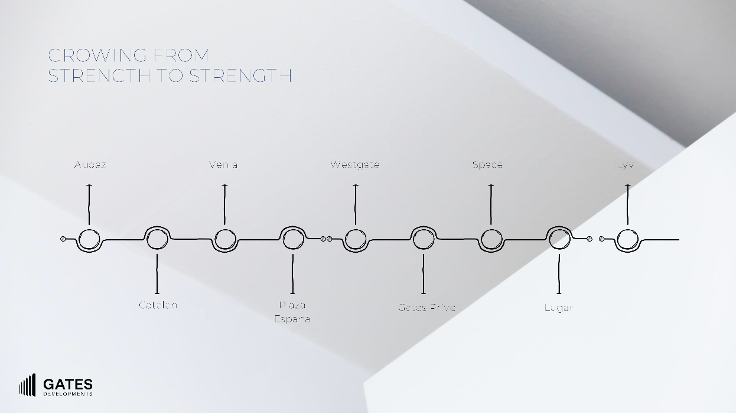

**CEO Information**

**The current CEO of Gates Developments is Hassan Nasr. He brings over 25 years of experience in real estate development and management to the role. His expertise in finance and operations is expected to drive the company's growth and success.**

**Nasr's vision for Gates Developments centers around:**

* **Diversification: Expanding the company's portfolio to include a wider range of projects.**
* **Growth Opportunities: Identifying and capitalizing on new market trends.**
* **Team Empowerment: Fostering a talented and dedicated workforce.**

**His leadership is expected to drive Gates Developments towards new heights of success.**

**Gates Developments Under Nasr's Leadership**

**Since taking the helm, Nasr has been instrumental in shaping the company's trajectory. Some notable achievements and initiatives under his leadership include:**

* **Strategic Expansions: The company has embarked on ambitious projects in various locations, such as the New Capital and the North Coast.**
* **Enhanced Project Portfolio: Gates Developments has diversified its offerings to include residential, commercial, and mixed-use developments.**
* **Stronger Market Presence: Nasr has been focused on solidifying the company's position as a leading player in the Egyptian real estate market.**

**Ownership**

**While there's limited publicly available information about the specific owners of Gates Developments, it's known that the company is privately held by a group of shareholders who share a passion for construction and real estate.**

**Developments**

**Gates Developments has a diverse portfolio of projects encompassing both residential and commercial spaces. Some of their notable projects include:**

**Commercial Projects**

* **Space Mall is a commercial, administrative, and medical project in El Sheikh Zayed City, Egypt. It's renowned for its unique design and strategic location ,rolling out on 8.5 acres**

**Key Features and Highlights**

1. **Location: Situated in the heart of El Sheikh Zayed, providing excellent accessibility.**
2. **Size: Occupies approximately 36,000 square meters (8.5 acres).**
3. **Design: Characterized by a modern and elegant aesthetic, with a strong emphasis on green spaces and landscaping. Renowned architect Raef Fahmi contributed to the project's design.**
4. **Composition: Consists of 17 standalone buildings, each with a ground floor and three upper floors.**
5. **Unit Types: Offers a mix of commercial, administrative, and medical units to cater to diverse needs.**
6. **Amenities: Includes a commercial strip, business hub, medical center, and underground parking.**
7. **Payment Plans: Provides flexible payment options to facilitate investment.**
8. **Total number of units 521**

**Additional Information**

* **Completion Date: Expected to be completed in 2028**
* **Target Market: A wide range of businesses and investors seeking commercial, administrative, or medical spaces.**

* **West Gate Business Hub is a commercial project located in the heart of 6th of October City, Egypt ,rolling out on 4 acres**

**Key Features and Highlights**

1. **Location: Strategically situated in 6th of October City, offering easy accessibility and a thriving business environment.**
2. **Design: Modern architecture with a focus on functionality and aesthetics.**
3. **Unit Types: A variety of office spaces to suit different business needs, including small offices, open-plan areas, and executive suites.**
4. **Amenities: State-of-the-art facilities such as high-speed internet, meeting rooms, and a business center.**
5. **Services: Comprehensive support services including cleaning, maintenance, and security.**
6. **Benefits of West Gate Business Hub**
7. **Prime Location: Enjoy the advantages of being in a prime business district with excellent transportation links.**
8. **Modern Infrastructure: Benefit from the latest technology and infrastructure to enhance productivity.**
9. **Flexible Spaces: Customize your workspace to meet the specific requirements of your business.**
10. **Professional Image: Enhance your company's image with a prestigious business address.**
11. **Networking Opportunities: Connect with other businesses and professionals in the same environment.**

**Additional Information**

1. **Target Market: Businesses of all sizes, from startups to established companies.**
2. **Amenities: In addition to the standard office amenities, West Gate Business Hub may offer additional facilities such as a gym, cafeteria, or retail spaces.**

* **Plaza Espana is a comprehensive commercial project located in Sheikh Zayed City, Egypt. It spans over 14,250 square meters and is divided into four distinct buildings, each catering to different commercial needs , rolling out on 4 acres**

**Key Features and Highlights**

1. **Location: Situated in the heart of Sheikh Zayed City, offering excellent accessibility.**
2. **Size: A substantial 14,250 square meters.**
3. **Composition: Four buildings dedicated to various commercial activities.**
4. **Unit Types: A mix of commercial, administrative, and medical units.**
5. **Amenities: A diverse range of amenities including a hypermarket, gym, spa, nurseries, car showrooms, cafes, restaurants, and shops.**
6. **Medical Facilities: Includes a dedicated building for medical clinics, a hospital, and bank headquarters.**
7. **Total number of units 150**

**Building Breakdown**

* **Building 1: Medical clinics, Al Safwa Hospital, bank headquarters, and a large hypermarket.**
* **Building 2: Gym, spa, nurseries, car showrooms, cafes, restaurants, and shops.**
* **Buildings 3 & 4: Administrative offices, cafes, and restaurants.**

**Unit Sizes**

* **Administrative Units: Range from 77 to 326 square meters.**
* **Commercial Units: Range from 43 to 423 square meters.**

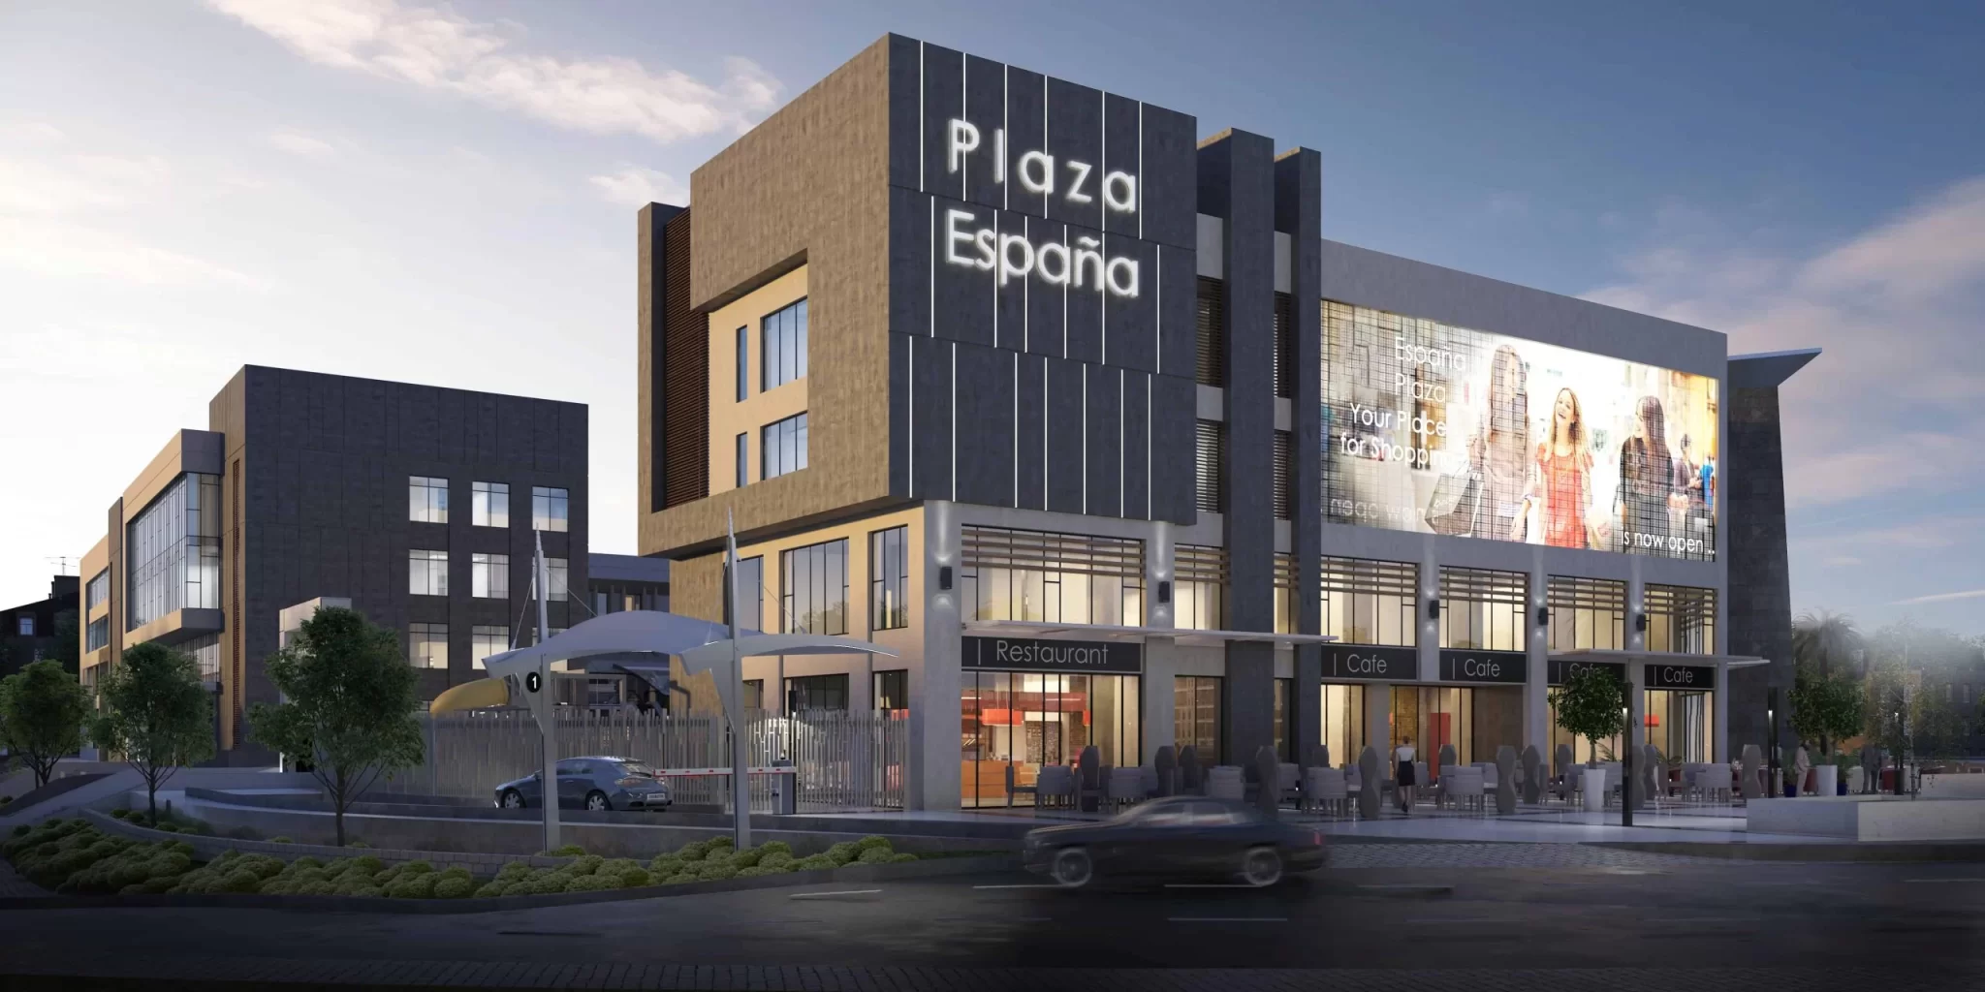

* **Audaz is a prominent commercial, administrative, and medical project developed by Gates Developments in the heart of the New Administrative Capital of Egypt. The name "Audaz" itself is Spanish for "bold," reflecting the project's innovative and ambitious approach rolling out on 4.15 acres**

**Key Features and Highlights**

1. **Location: Strategically situated in the New Capital's financial district, offering excellent visibility and accessibility.**
2. **Size: Occupies a substantial area of 16,800 square meters.**
3. **Design: Modern and contemporary architecture, emphasizing functionality and aesthetics.**
4. **Composition: Consists of two main buildings (A and B) housing a variety of commercial, administrative, and medical units.**
5. **Unit Types: Offers a diverse range of spaces to accommodate different business needs, including offices, clinics, retail outlets, and commercial shops.**
6. **Amenities: Provides essential amenities for tenants and visitors, such as parking, security, and maintenance services.**
7. **Project Highlights**
8. **Prime Location: Benefits from its strategic position in the New Capital's financial district, attracting a high-end clientele.**
9. **Mixed-Use Development: Caters to a wide range of businesses and investors, maximizing investment potential.**
10. **Modern Design: Offers a contemporary workspace that enhances productivity and employee satisfaction.**
11. **Investment Opportunities: Presents attractive investment options due to the project's location and the growing demand for commercial spaces in the New Capital.**

**Residential Projects**

* **Gates Privé This exclusive compound in Sheikh Zayed City is renowned for its French-inspired architecture, lush green spaces, and unparalleled privacy , rolling out on 17 acres**

**Key Features**

1. **French-Inspired Design: The compound exudes elegance and sophistication with its French architectural elements.**
2. **Prime Location: Situated in a prime area of Sheikh Zayed City, providing easy access to major roads and amenities.**
3. **Privacy and Security: Gates Privé prioritizes the safety and privacy of its residents with advanced security systems.**
4. **World-Class Amenities: The compound boasts a wide range of amenities, including swimming pools, fitness centers, spas, and landscaped gardens.**
5. **Limited Units: With only 98 units, Gates Privé offers an exclusive and intimate living experience.**

**Lifestyle and Amenities**

**Residents of Gates Privé can enjoy a truly exceptional lifestyle with access to:**

1. **Luxurious Clubhouse: A social hub for residents to relax and entertain.**
2. **Landscaped Gardens: Serene green spaces for outdoor relaxation and recreation.**
3. **State-of-the-Art Fitness Center: Maintain a healthy lifestyle with modern workout facilities.**
4. **Spa and Wellness Center: Indulge in pampering treatments and rejuvenate your senses.**
5. **Children's Play Area: A safe and fun environment for young residents.**

* **Lugar is a prestigious residential compound in the heart of Sheikh Zayed City, Egypt. It offers a harmonious blend of modern living and natural surroundings, rolling out on 65 acres**

**Key Features**

1. **Strategic Location: Situated in a prime area of Sheikh Zayed, providing easy access to major roads and amenities.**
2. **Sustainable Design: Lugar emphasizes environmental sustainability with a focus on green spaces and energy efficiency.**
3. **Diverse Unit Types: The compound offers a variety of residential options to suit different lifestyles, including apartments, villas, and townhouses.**
4. **World-Class Amenities: Residents can enjoy a range of facilities such as swimming pools, fitness centers, spas, and children's play areas.**
5. **Total number of units 862**
6. **Expansive Green Spaces: Lugar boasts lush landscapes and open spaces, creating a serene living environment.**
   * **Lifestyle and Amenities**
   * **Residents of Lugar can experience a fulfilling lifestyle with access to:**
7. **Clubhouse: A social hub for residents to relax and socialize.**
8. **Landscaped Gardens: Tranquil green spaces for outdoor relaxation and recreation.**
9. **Swimming Pools: Refreshing escape from the summer heat.**
10. **Fitness Center: Maintain an active lifestyle with state-of-the-art equipment.**
11. **Children's Play Area: A safe and fun environment for young residents.**

* **Lyv Caesar is a luxurious coastal resort in the heart of Ras El Hekma, Egypt.**

**This stunning project offers a unique blend of beachfront living, modern amenities, and breathtaking natural beauty, rolling out on 206 acres**

**Key Features**

1. **Prime Location: Situated on the pristine shores of the Mediterranean Sea, Lyv Caesar offers unparalleled access to the beach.**
2. **Modern Design: The resort features contemporary architecture and stylish interiors.**
3. **Diverse Unit Types: A wide range of residential options, including villas, townhouses, and chalets, to cater to different preferences.**
4. **World-Class Amenities: Residents can enjoy a plethora of amenities such as swimming pools, water sports, spas, fitness centers, and children's play areas.**
5. **Expansive Green Spaces: Lush landscapes and gardens create a serene and relaxing atmosphere.**
6. **Total number of units 2500**

**Lifestyle and Amenities**

**Lyv Caesar offers a truly exceptional lifestyle with:**

1. **Private Beach Access: Enjoy the sun, sand, and sea at your doorstep.**
2. **Water Sports: Engage in exciting water activities like swimming, diving, and windsurfing.**
3. **Spa and Wellness: Relax and rejuvenate with a variety of spa treatments.**
4. **Dining and Entertainment: Experience a wide range of culinary delights and entertainment options.**
5. **Children's Clubs: Keep the little ones entertained with dedicated play areas and activities.**
6. **Lagoon area 55,000 sqm**
7. **Area of sand beach 400 sqm**
8. **Area of pools 21,000 sqm**

* **Catalan Compound is a residential project in the New Administrative Capital of Egypt. It's positioned in the seventh residential district (R7), offering a strategic location within the city ,rolling out on 40 acres**

**Key Features**

1. **Location: Strategically situated in R7, New Capital City.**
2. **Size: Covers an area of approximately 16,500 square meters (40 acres).**
3. **Unit Types: The compound offers a variety of residential units, including apartments and duplexes.**
4. **Amenities: Catalan provides a range of amenities for residents, such as swimming pools, landscaped gardens, and recreational areas.**
5. **Design: The project emphasizes modern architecture and comfortable living spaces.**

* **Venia is a prestigious residential compound in the heart of the New Administrative Capital of Egypt. It offers a contemporary lifestyle with a focus on comfort, luxury, and sustainability.**

**Key Features**

1. **Prime Location: Strategically situated in R7, New Capital City, providing easy access to major roads and amenities.**
2. **Modern Design: Venia boasts a contemporary architectural style with a focus on open spaces and natural light.**
3. **Diverse Unit Types: The compound offers a variety of residential options, including apartments and duplexes, to suit different lifestyles.**
4. **World-Class Amenities: Residents can enjoy a range of facilities such as swimming pools, fitness centers, spas, and landscaped gardens.**
5. **Sustainability: Venia incorporates eco-friendly features and practices to promote a sustainable living environment.**

**Lifestyle and Amenities**

**Residents of Venia can experience a fulfilling lifestyle with access to:**

1. **Clubhouse: A social hub for residents to relax and socialize.**
2. **Landscaped Gardens: Tranquil green spaces for outdoor relaxation and recreation.**
3. **Swimming Pools: Refreshing escape from the summer heat.**
4. **Fitness Center: Maintain an active lifestyle with state-of-the-art equipment.**
5. **Children's Play Area: A safe and fun environment for young residents.**

**Future Projects**

**Gates Developments has ambitious plans for future growth and expansion. The company is actively exploring new opportunities in the real estate market and is expected to announce new projects in the coming months.**